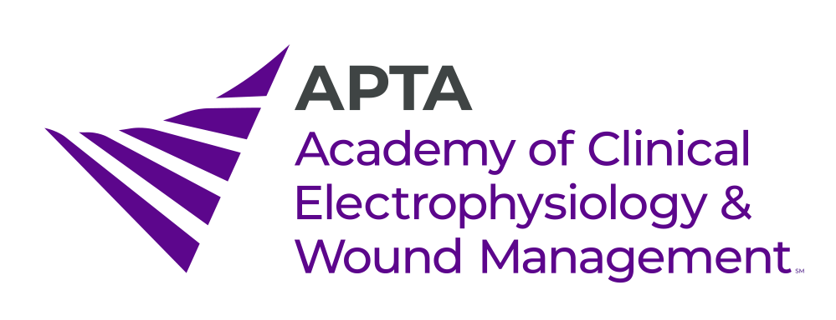
2920 East Avenue South, Suite 200
La Crosse, WI 54601
608-351-2735
acewm@libertysquaregroup.com www.acewm.org
Sponsorship Levels & Recognition
Sponsor Level Recognition

$2,500 Platinum Level Academy Sponsor
- Logo on Academy website with link to company/organization website for 12 months
- Article about company in Academy electronic newsletter for 6 issues
- Banner sign of company logo at up-coming CSM* Booth and logo included on signs at CSM meetings
- Verbal recognition at the Academy’s Annual Meeting

$2,000 Gold Level Academy Sponsor
- Logo on Academy website with link to company/organization website for 9 months
- Article about company in Academy electronic newsletter for 3 issues
- 18” x 24” easel sign with company logo at up-coming CSM Booth and logo included on signs at CSM meetings
- Verbal recognition at the Academy’s Annual Meeting

$1,500 Silver Level Academy Sponsor
- Logo on Academy website with link to company/organization website for 6 months
- Article about company in Academy electronic newsletter for 1 issue
- 12” x 18” easel sign with company logo at up-coming CSM Booth and logo included on signs at CSM meetings
- Verbal recognition at the Academy’s Annual Meeting

$750 ea. Special Interest Group (SIG) Sponsor
Select one or more (Biophysical Agents SIG, Electrodiagnosis SIG, Neuromusculoskeletal Ultrasound Imaging SIG, Wound Management SIG)
- Logo on Academy website with link to company/organization website for 3 months
- Logo included as “SIG Sponsor” on signs at CSM meetings

$250 General Sponsor
- Logo on Academy website with link to company/organization website for 1 month

$250 Sponsor a Physical Therapist or Physical Therapist Assistant Student
- Logo on Academy website with link to company/organization website for 1 month
- Recognition in electronic newsletter with student recipient
- Recognition at the ACEWM Booth at up-coming CSM

*CSM = APTA’s Combined Sections Meeting

Contact the ACEWM at acewm@libertysquaregroup.com for further information and payment options

2920 East Avenue South, Suite 200
La Crosse, WI 54601
608-351-2735
acewm@libertysquaregroup.com www.acewm.org

Sponsorship Benefits and Recognition Confirmation Form

COMPANY NAME

ADDRESS
PHONE NUMBER_____________________________ FAX NUMBER ___________________________
CONTACT PERSON____________________________ E-MAIL_________________________________

Level of Sponsorship & Recognition | Amount

Total

Email this form to acewm@libertysquaregroup.com to confirm your intent for sponsorship and to

receive payment and logo submission instructions

Upon receipt of this form, the ACEWM Executive Director will send further instructions regarding payment and company logo/information. We appreciate your sponsorship of the ACEWM.

Sponsorship Payment & Company Logo/Information Instructions

As confirmed on the returned Sponsorship Benefits and Recognition Confirmation Form, please see below for instructions on payment and how to submit your company logo and any other information required for your specific level of sponsorship.

Payment Options
- Credit Card
To submit your sponsorship payment please use the Square links below:
- Platinum Level - $2,500: https://square.link/u/3fNAsIlM
- Gold Level - $2,000: https://square.link/u/8agJbaZV
- Silver Level - $1,500: https://square.link/u/KGT7utxX
- Special Interest Group Sponsor - $750: https://square.link/u/HRg6HCwd
- General Sponsor - $250: https://square.link/u/MpEIbRAw
- Sponsor a PT or PTA Student -$250: https://square.link/u/8co31gyZ
- Check
  - Payable to the Academy of Clinical Electrophysiology & Wound Management
  - Mail to Christie Krueger, Executive Director, ACEWM, 2920 East Avenue South, Ste 200, LaCrosse, WI, 54601

Company Logo / Information:
Logos must be supplied by the sponsor and can be provided in JPEG or PNG format. Dimensions of the artwork/graphic file should be 750 pixels wide x 380 pixels high. Text to be uploaded for the ACEWM electronic newsletter or website should be submitted as a .doc or .pdf file. Logos and all information should be emailed to acewm@libertysquaregroup.com.

Thank you for sponsoring the ACEWM!
Contact Victor Vaughan at vic@libertysquaregroup.com with questions

