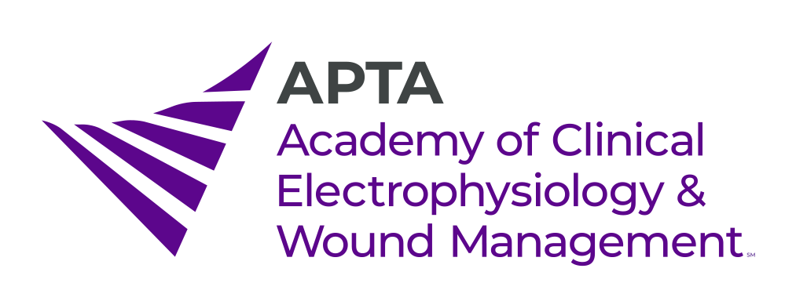
Neuromusculoskeletal Ultrasonography Special Interest Group (SIG)
Potential Candidate Form

INSTRUCTIONS: The Neuromusculoskeletal Ultrasonography Special Interest Group Nominating Committees are seeking recommendations for the 2021 Slate of Candidates. If you have been recommended for SIG office and have consented to serve, or if you wish to nominate yourself, please complete this form. Type your answers and email them, along with the requested materials listed at the bottom of this form to Beshoy Ghaly, the NMSKUS-SIG Nominating Committee Chair at ghaly.beshoy@gmail.com on or before April 15, 2021.

This information will only be viewed by the applicable SIG’s Nominating Committee to assist them in getting to know potential candidates better. Please keep your responses brief. If you have any questions, please contact info@acewm.org.

Deadline for submission: April 15, 2021.

Position within the SIG:
____ Vice-Chair
____ At-Large Officer

- Why do you want to serve in the role for which you have consented?

- What experience, talents, and skills would you bring to the role for which you have consented?

- When you are part of a group or team, what are your strategies to help the team build consensus on a decision that cannot be agreed upon? Please provide an example below.

___ I consent to serve according to the applicable ACEWM policies & procedures.

Name of Applicant: __________________________________ Date: _____________
Attachments:
Resume: Please include a resume/CV as a separate document.

